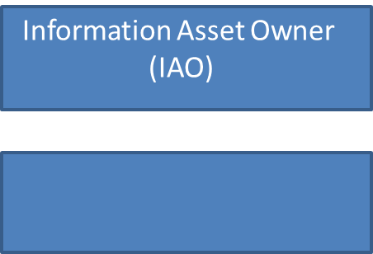

Chief Executive (Accounting Officer) **Silas Nicholls**

Senior Information Risk

Owner

(Board Level Position)

**Richard Mundon**

Information Asset Owner

(IAO)

Information Asset Owner

(IAO)

Information Asset

Administrator

Information Asset

Administrator

Information Asset

Administrator

Information Asset

Administrator